

brief for scheduling needs

1. Problem Overview
QuickBite operates a delivery fleet that must serve 30 orders across five zones. Each order has a time window during which it should be delivered. The goal is to assign orders to vehicles and sequence each vehicle’s route to minimize a composite cost that includes various factors such as travel time, time-window violations, capacity overflow, workload imbalance, driver preferences, and express-order lateness.

2. Geography and Zones
The city has one depot and five delivery zones:
Idx | Zone Name | Description | Visual Representation
0 | Depot (Central) | Starting/ending point for most vehicles | 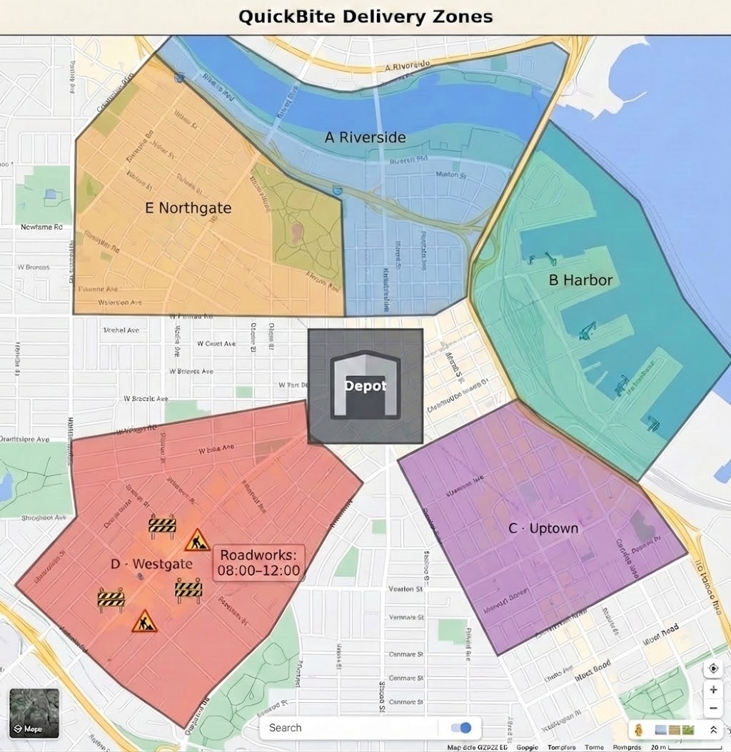
1 | A (Riverside) | Delivery zone
2 | B (Harbor) | Delivery zone
3 | C (Uptown) | Delivery zone
4 | D (Westgate) | Delivery zone (has roadworks 08:00–12:00)
5 | E (Northgate) | Delivery zone

3. Traffic and Travel Time
Below is an estimate of travel time between each area. For example, in normal traffic, traveling from Depot to A and then from A to B will take 12 and 8 minutes, respectively. For simplicity, trips within the same zone are normally negligible.

 Depot A B C D E
Depot [ 0, 12, 18, 25, 30, 22 ]
A [ 12, 0, 8, 15, 20, 14 ]
B [ 18, 8, 0, 10, 18, 12 ]
C [ 25, 15, 10, 0, 9, 11 ]
D [ 30, 20, 18, 9, 0, 7 ]
E [ 22, 14, 12, 11, 7, 0 ]

Keep in mind that travel times vary by time of day and conditions. The above matrix only represents the basic travel time. However, depending on the time of day, the actual travel time can be different:
- General traffic conditions:
  - Period 1 (07:00–09:30): morning peak
  - Period 2 (09:30–11:30): normal
  - Period 3 (11:30–13:00): lunch surge
  - Period 4 (13:00–16:00): normal
  - Period 5 (16:00–18:00): evening peak

- Zone D roadworks (08:00–12:00): extra time to any trip involving Zone D, regardless of traffic period.

- Stochastic noise: total travel time fluctuates by a small factor.

Since the city owns the traffic data, an API has been offered to implement this logic and estimate the travel time similar to common navigation services.

4. Vehicles
The delivery crew of interest has five vehicles with different capacities, start locations, and shift start times:

ID | Name | Capacity | Start Zone | Shift Start | Max Hours
0 | Alice | 22 | Depot (0) | 08:00 | 8h
1 | Bob | 20 | Depot (0) | 08:00 | 8h
2 | Carol | 20 | Depot (0) | 09:00 | 8h
3 | Dave | 22 | Depot (0) | 08:00 | 8h
4 | Eve | 20 | Zone E | 09:30 | 8h

- Capacity is in units; total load per route must not exceed it.
- Shift start: vehicle cannot depart before this time.
- Max hours: shift cannot exceed 8 hours.
- Compensation and fairness: drivers are assumed to be salaried (or compensated under a pooled/guaranteed-hours scheme), so the scheduler aims to keep routes operationally efficient while maintaining fair workloads (driving + service time) across drivers
- Driver preferences: some drivers have preferences not listed above (see §6).

A copy of the driver information has been formatted into a .csv file for potential upload.

5. Orders
30 orders have been created. Each order contains the following information:

Variable | Type | Description
order_id | str | O00 … O29
zone | int | 1–5 (delivery zone)
size | int | 1–5 units (from [1, 2, 3, 4, 5])
priority | str | "express" or "standard"
time_window_open | int | Minutes since midnight (08:00–14:00, 30‑min slots)
time_window_close | int | time_window_open + duration in [60, 90, 120, 150]
service_time | int | 15 min (express) or 10 min (standard)

Order list:

ID Zone Size Priority Window Open Window Close Svc
----------------------------------------------------------------------
O00 E 1 standard 09:30 12:00 10
O01 B 4 standard 10:00 12:30 10
O02 A 1 standard 08:30 10:30 10
O03 A 2 standard 12:00 13:30 10
O04 E 4 standard 10:30 12:30 10
O05 A 3 standard 08:30 11:00 10
O06 D 4 express 08:00 09:30 15
O07 B 2 standard 13:00 14:00 10
O08 D 4 standard 14:00 16:00 10
O09 A 1 standard 10:30 12:30 10
O10 A 5 standard 10:00 11:30 10
O11 C 3 standard 08:30 10:00 10
O12 B 2 standard 11:30 14:00 10
O13 C 4 standard 09:30 11:00 10
O14 E 2 express 13:30 14:30 15
O15 E 5 express 10:00 11:00 15
O16 A 5 express 11:30 14:00 15
O17 A 2 standard 09:30 10:30 10
O18 A 2 standard 09:00 10:00 10
O19 D 3 standard 08:00 10:30 10
O20 B 1 standard 13:30 15:30 10
O21 D 3 standard 09:30 11:30 10
O22 D 4 standard 09:30 10:30 10
O23 B 3 standard 12:30 14:30 10
O24 B 5 standard 13:30 14:30 10
O25 D 3 express 08:00 10:00 15
O26 A 4 standard 09:30 10:30 10
O27 E 1 standard 12:00 13:30 10
O28 C 4 standard 13:30 15:00 10
O29 A 1 standard 12:00 14:00 10

Special notes for delivery:
- If the vehicle arrives before Window Open, it waits until Window Open.
- Then, Service Time is added to the clock to obtain the departure time.
- Time-window violations and express lateness are based on arrival vs. Window Close only (not on when service finishes), but the service time contributes to shift duration.
- Late delivery of express orders should be avoided, as it can result in more profit loss.

A copy of the order list has been formatted into a .csv file for potential upload.

6. Additional Preferences
Some drivers in the crew have stated preferences:
- Alice prefers to avoid Zone D stops,
- Carol dislikes express orders, and
- Dave prefers to avoid long shifts as he may get less efficient after 6.5h.

These preferences are soft (mismatches are allowed), but they may be reflected in the optimization formulation and programming when possible.

Note: This document's content is intended for a hard copy to be presented to the participant alongside a presentation. Please be aware that some modifications may be made to this content before the study, owing to potential changes in the prototype system's interface and bug fixes. These changes are not expected to impact user expectations or potential risks associated with the study.

